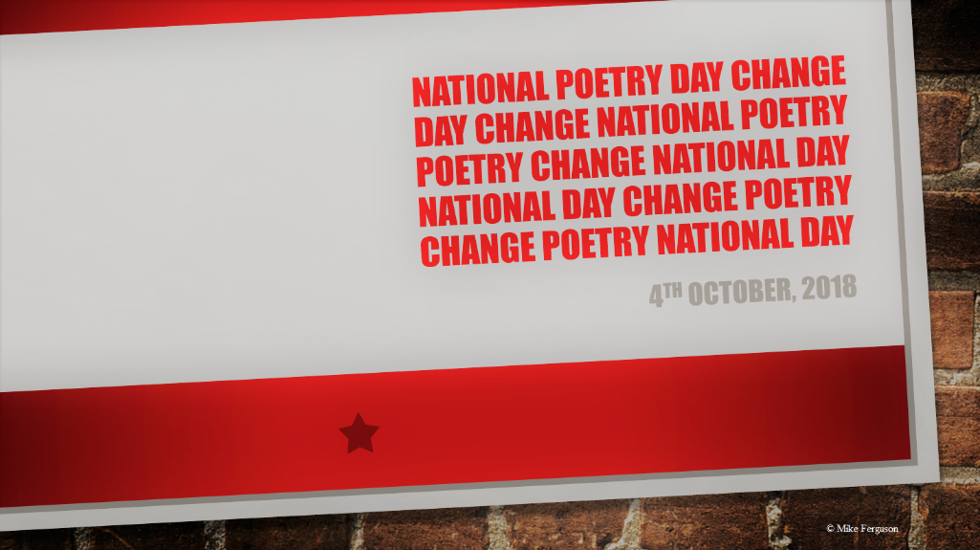

Blue Mood Poet

He is reciting
baby blue

muffled poems
as if through

a cloudless
morning sky,

words filtered
by a soft

mask of beauty
to clarify.

